Overview  Image Basics  Configuration Files  Putting It All Together | 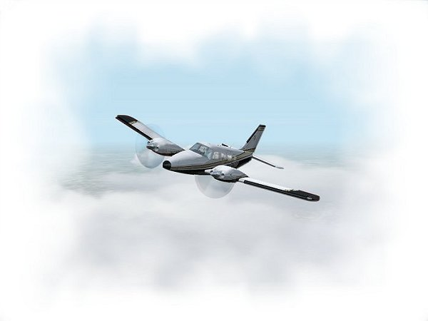

Overview
These instructions are not intended as a tutorial on how to repaint Flight Simulator aircraft, or how to best use your Windows paint program of choice. If you are looking for a good tutorial on this subject, you might want to check out Eric Joiner’s excellent treatise here.

This paper is intended to give you basic guidelines on how the texture formatting of the Seneca works, and how you can use these files to create and format a new paint scheme.

In Flight Simulator 2002, additional paint schemes for any individual aircraft can be added by creating a new, complete texture set, and adding these textures to a new folder in the aircraft’s directory structure using the naming convention texture.***. Where “***” is the unique folder name you wish to use.
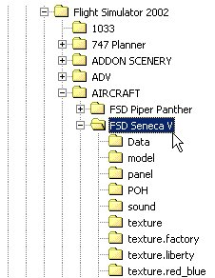

For example, if you are creating a Korean Air Force texture scheme, you might want to name this texture folder:

texture.gold_red

We recommend you absolutely avoid using naming schemes such as “texture.2”, “texture.3”, as you never know who else will be uploading new texture schemes, and such generic naming will most certainly result in duplications.

Since the Seneca was provided with an automated Load Manager, your add-on paint scheme should ideally be formatted to work with that utility. This instruction set will show you how to configure your paint scheme to work seamlessly with this utility.

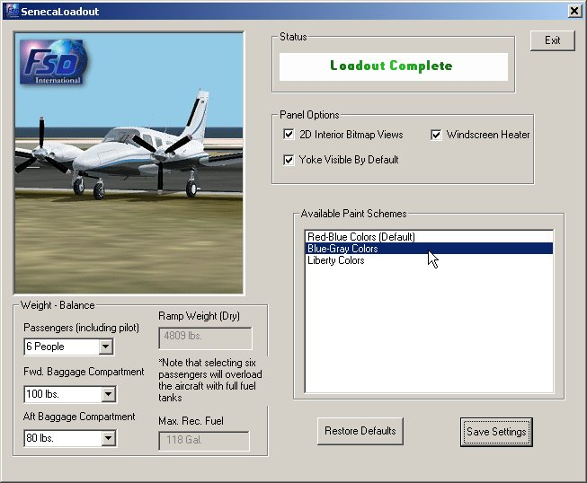

Finally, we will provide you with some basics on how to construct your upload file.

Image Basics
The working files you have downloaded are in *.psp Adobe Photoshop format, which is considered the industry standard. This format is also recognized by many popular Windows paint programs, such as JASC PaintShop Pro© 7 and Corel Draw©.  Simply open the file with the program of your choice. | 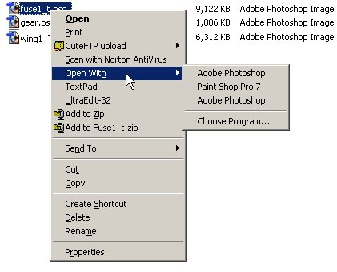

As previously mentioned, these instructions are not intended to be a tutorial on how to paint aircraft, or use any specific paint program. These are simply basic instructions on how to work with these files.

This download contains five working files in the Templates folder: | 1. fsdseneca1_T_kit.psd | – fuselage texture
 | 2. fsdseneca2_T_kit.psd | – gear doors/lower fuselage
 | 3. fsdseneca3_T_kit.psd | – wing sections
 | 4. fsdseneca4_T_kit.psd | - misc. parts
 | 5. fsdseneca5_T_kit.psd | - misc. parts

These are the sections of the aircraft that can be repainted. The working images are layered *.psp images. Each individual layer is given a descriptive label to allow you to create precise textures.

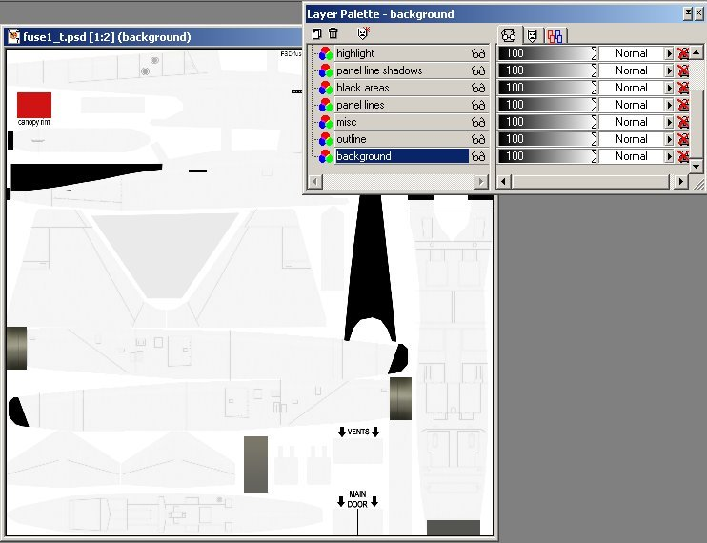

When you are satisfied with your work, make sure you flatten the image and save it, using the same file name, but with a .bmp extension.

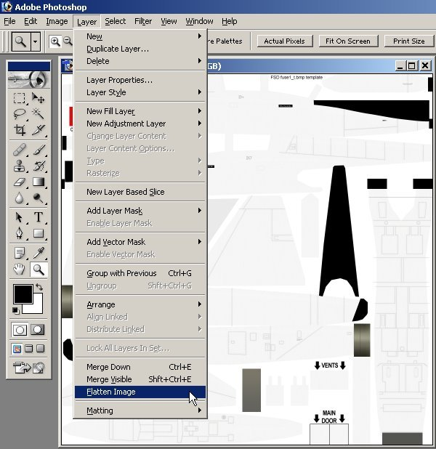

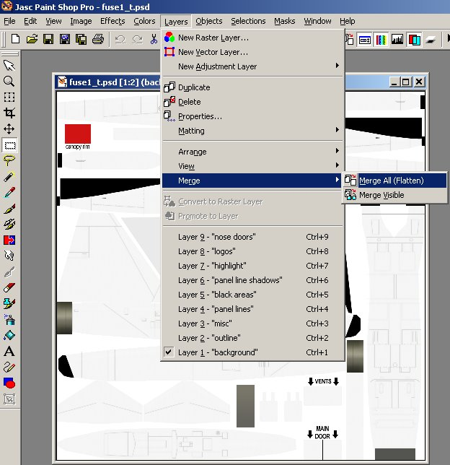

We recommend using DXT 16-bit extended bitmap format for these aircraft textures, for best simulator performance. The program DXTBmp by Martin Wright is an excellent tool for this application. You can also use Microsoft’s Image Tool, which is available in the FS 2000 Scenery SDK.

Configuration Files
The Seneca was released with a Load Manager, which will allow users to add paint schemes quickly and easily. The Load Manager finds add-on texture folders, fills in all missing textures, and formats the Seneca Aircraft.cfg file automatically, so that the new paint scheme will be available in the FS 2002/Select Aircraft menu.

In order to accomplish this, the Load Manager makes use of two configuration files, which must be located in the add-on paint scheme’s texture folder:

Paint.cfg | Contains display information on how the new paint scheme will be displayed in the Load Manager’s information window, and in the FS 2002 Select Aircraft menu
Aircraft.bmp | Image to display in the Load Manager’s view window.

Paint.cfg File
The Paint.cfg file within each texture folder determines how the new paint scheme will be displayed in the Load Manager’s View Window, and also, contains entry data for how it will be described in the Select Aircraft menu in Flight Simulator. The Paint.cfg file contains six entries:

scheme= | Defines how the entry will be displayed in the Load Manager’s information window
ui_variation= | Defines how the paint scheme will be defined in the Seneca Aircraft.cfg file, and in the FS 2002 Select Aircraft menu
texture= | Literal name of the texture folder you have chosen. For example, the texture folder name for the Liberty paint scheme is texture.liberty. The entry in the Paint.cfg file is texture=liberty
atc_id= | Defines the tail number for the Aircraft.cfg file, and for the FS 2002 ATC feature.
title= | Unique title for the entry in the Aircraft.cfg file. Make this name as unique as possible, to reduce the possibility of duplication with someone else’s paint scheme. The FS 2002 menu system will not deal with duplications!
description= | Another entry for the Aircraft.cfg file.

Best results will be obtained by not adding any space between the entry’s “=” sign and the data. Here is an example for the Liberty colors included with the Seneca. The paint scheme is located in a folder titled texture.liberty:

scheme=Liberty Colors
ui_variation=Liberty Colors
texture=liberty
atc_id=N72153
title=FSD Seneca V Liberty
description=Paint Scheme By Owen Hewitt.

The Load Manager also utilizes a view window, so that users can see what the individual paint scheme looks like. It is a convenience feature, and is in fact optional. If no image is provided, the Load Manager will display this image:



If you don’t want your new paint scheme to look like this, you will want to provide your own image for users to see:

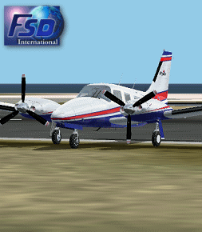

The image should ideally be 255 x 290 pixels. It can be either 8-bit (256 color) or 24-bit (16 million color). The name of the image must be:

Aircraft.bmp

In practical terms, you will find that you likely will not loose image quality reducing the image memory size to 256 colors, but the difference in file size is significant. So from the standpoint of economizing on bandwidth, we recommend you use 8-bit 256 color images. But it is your choice.

Putting It All Together

Since the Load Manager formats everything for the user, and copies all of the generic textures you did not paint from the aircraft’s main texture folder automatically, it is not necessary, and not desirable for you to upload all 18 aircraft textures for your new paint scheme. The only files you should upload are the ones you repainted. The Load Manager scans the aircraft folder structure when it is executed. If it finds these five textures:

fsdseneca1_T.bmp
fsdseneca2_T.bmp
fsdseneca3_T.bmp
fsdseneca4_T.bmp
fsdseneca5_T.bmp

It will recognize the folder as a new texture set, and copy the other textures from the primary texture folder automatically. If you do repaint an additional texture, such as glass_T.bmp, the Load Manager will recognize it, and will not overwrite it. But from the standpoint of economizing on bandwidth, it is certainly wasteful to upload files unnecessarily. So give the folks who will be downloading this a break. Just upload the files you repainted, and let the Load Manager do the rest.

Zip It Up

The best way to do this is make a new folder on your hard drive, called “Upload”, for example.

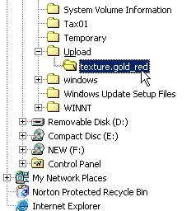

Inside that folder, create a sub-folder titled as you want it to appear inside the Flight Simulator 2002\AIRCRAFT\FSD Seneca V directory structure. Place your finished repainted * .bmp files, your Aircraft.bmp file, and your Paint.cfg file inside that sub-folder. We recommend you format your zip file according to the flightsim.com website’s Developer’s Tips. This format will pretty much be suitable for wherever you want to upload. The FSD Development Team highly recommends the flightsim.com file library. You will want to put your zip file together like this:

File_ID.diz | Contains the text as you want it to appear in the file library description
*.*.gif | Small screenshot of the aircraft with your paint scheme, as it will appear in the file library
Readme.txt | Some basic instructions for the user
Texture Folder | Named as above, like texture.KoreanAF, etc. Contains your completed files.

So your Upload folder you created should look something like this:

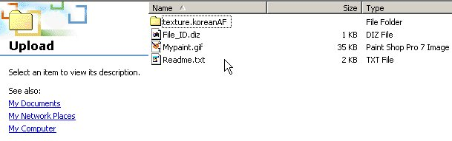
Then just zip this file up, using WinZip, or a comparable program, and you are set to go!

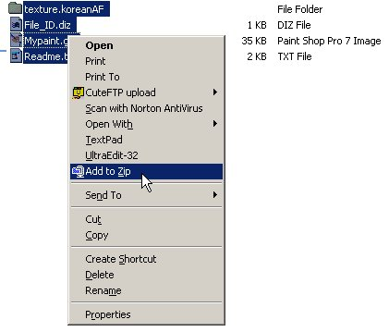

Copyright And Distribution

The texture files being repainted remain the copyrighted property of FSD International. Repainting the Seneca is fine as long as appropriate reference is made in your uploaded file, referring to the original authors (FSD), and as long as you do not distribute copyrighted files other than the five files listed in this document.

At no time may repaints, or any copyrighted FSD files, be placed on a web site, newsgroup, Internet mailing list, or Bulletin Board (BBS) that requires download or membership fees. Any attempts to distribute or alter the files outside of these rules will be considered an act of piracy and will be dealt with according to applicable law. All such acts of piracy, including unauthorized uploading and distribution as outlined above, will be disclosed publicly by FSD on any/all Internet forums, newsgroups, Bulletin Boards. Such disclosure will include the names and Internet/mail addresses of the offenders. We take these infringements on our rights very seriously.

Copyright © 2002 FSD International. All rights reserved.

